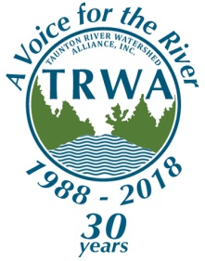
Taunton River Watershed Alliance

P.O. Box 1116, Taunton, MA 02780

(508) 828-1101
TAUNTON RIVER FESTIVAL
Sunday, June 10th, 2018
Educational and Informational Space Application

ORGANIZATION NAME: _______________________________________________________
CONTACT NAME: ____________________________________________________________
ADDRESS: ____________________________________________________________________
CITY: ________________________________________________________________________
TELEPHONE #: DAY: (____)_________ EVE: (____)___________ FAX:(____)________
Describe Your Exhibit: ________________________________________________________ ______________________________________________________________________________
Space Size Requested: _________’ X __________’
Special Requirements: _______________________________________________________
Where did you hear about the Taunton River Festival? _________________________
PLEASE READ THE FOLLOWING CAREFULLY, SIGN, AND DATE:
I have read the enclosed instructions and agree to abide by them. I will not hold the TRWA, its members or its volunteers responsible for damage, loss, or injury, nor be a party to any legal action against them. No fee will be charged per space. Subject to guidelines of the committee, we have the right to refuse.
SIGNATURE: _______________________________ PRINT NAME: __________________________
TITLE: _____________________________________ DATE: _________________________________
If you have any questions, call the TRWA office at (508) 828-1101
Please retain a copy of this form for your records

